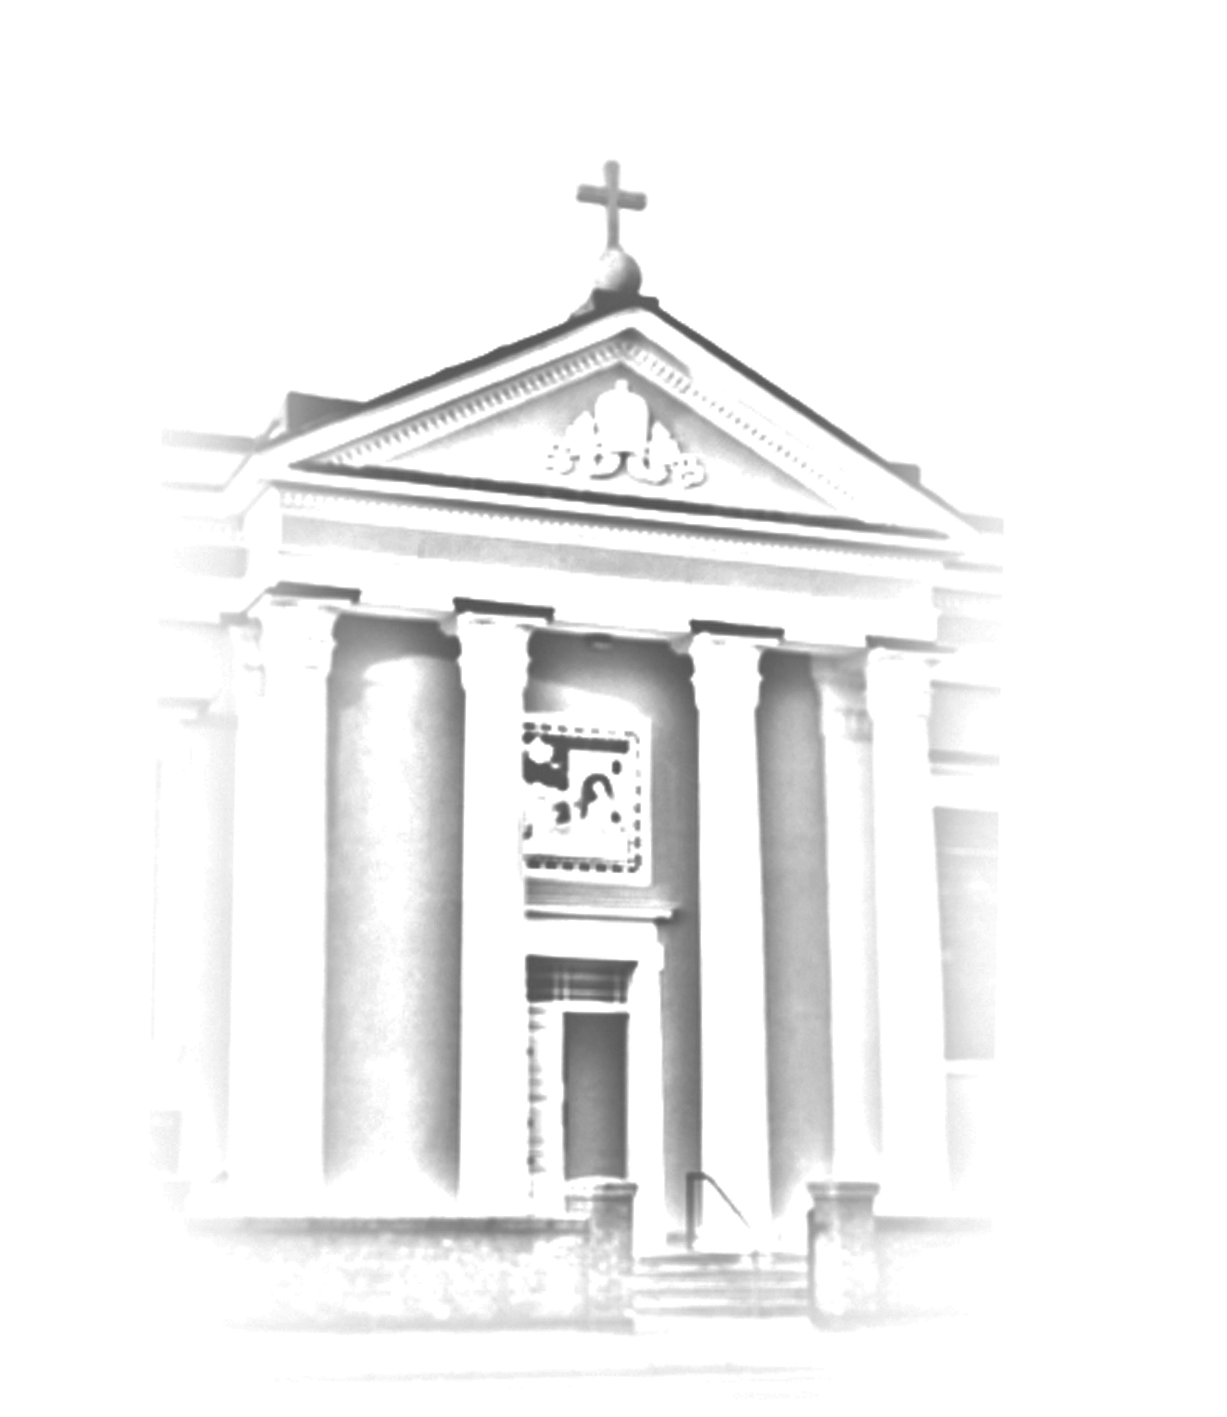

St. Mary’s Catholic Church
97 Ashby Road, Loughborough LE11 3AB
Tel: 01509 262123
Email: newsletter@stmarysloughborough.org.uk
Web: www.stmarysloughborough.org.uk

Served by the Rosminians:
Fr Philip Sainter, Fr Charles Sormany, Fr Simon Giles

Volunteers – CHURCH FLORAL DECORATIONS:
We are a team of four. The Church flowers are done weekly on a Friday. We meet at 12pm after the cleaners have finished their good work and if we have a special event like a wedding, Christmas, Easter and the Harvest Festival, then we do spend a lot more time on our flower arrangements to make them extra special. At Christmas, for example, we spent three days on our arrangements to make them fit for the celebration of the Birth of Our Lord. On these special occasions, and with Christmas on the way, we are always looking for greenery .. so if you have a garden that needs a little pruning we would be grateful for whatever you can spare us and are quite happy to collect if you let us know your details.

If you are interested in flower arranging, there is always room for more to join the team - you would be more than welcome! It doesn't mean you have to be there every week - for the big events, if you prefer, you can support us by clearing, tidying up and making the tea, as this is also a big help.

Flowers can be quite expensive, so if you would like to make a donation for a special occasion this would indeed be welcomed! Some people give a donation for a special arrangement of their choice for the Altar.

Weddings: the team really enjoy doing these; it's nice to do something a little different – we can work to the colour of your choice and we are cheaper than the florists!

If you require any more information or can help in any way, please contact Bernie McEnery on berniemcenery@yahoo.co.uk or 07919 865410.
_________________________

NEW PARISH COORDINATOR: Louise Lambert started this week as our new Office Coordinator. As you will appreciate, this role is critical to the smooth running of parish activities and we welcome her warmly. Most weeks she will work Wednesdays and Fridays, from 10am ‘til 2pm. Louise will handle hall bookings, Mass intentions and other parish communications. She will act as the communication lynchpin for the parish and can be contacted on office@stmarysloughborough.org.uk. Louise lives in Rearsby and will need to get to know people, especially ministry and group representatives. If you meet her please introduce yourself and let her know what you are involved in.

NEW PASTORAL PARISH COUNCIL The first meeting of the new Parish Council was held last week and we warmly welcome Bernie McEnery, Eddie Orton, Gabrielle Remedios and Ruth Busby as new members. We have a day together organised for 23 November when we will review the past year and reflect on what will be our main focus and mission, in support of the parish, during the next year. If you have any suggestions or comments please speak to a member of the PPC, Father Philip or email ppcchair@stmarysloughborough.org.uk We will be holding another open parish meeting before Christmas.

THE SHROUD OF TURIN: Replica on display at the Cathedral Hall of St. Barnabas, North Circus Street, Nottingham NG1 5AE, 27th October – 1st November 2013 inc. We strongly encourage you to visit it! More information about this powerful and moving symbol of Christ’s resurrection can be found in our latest issue of Parish Voice magazine, which is available after all Masses – suggested donation £1.

OCTOBER MONTH OF THE ROSARY: www.therosary3.com – a beautiful place where you can simply contemplate Jesus and Mary. This is God’s work, created with love and it purely seeks to enrich people’s faith through what has always been a beautiful prayer.

Newsletter for Sunday, 20th October 2013

29th Week of Ordinary Time - Psalter Week 1

WORLD MISSION SUNDAY

WORLD MISSION SUNDAY

We welcome Don Vito Nardin to St Mary’s,
Loughborough
_________________________________

Don Vito Nardin was born on 29th August 1945 at Faver (TN), very near to the birthplace of Blessed Antonio Rosmini. He came to know the Rosminians as an aspirant and then entered the novitiate in 1960. Following final vows in 1967, he was ordained priest in June 1972 in his home town. Recognised by many who know him as a humble and saintly man, he is well versed in the Rosminian Charism and spirituality and has a wonderful gift of accompanying and inspiring young people.

Don Vito has been parish priest in Santa Ninfa (TP – Sicily) and Santo Spirito (EUR Rome); He was Provincial Superior of the Rosminians in Italy and from 2003 was based at the Sacro Monte Calvario as Rector, Director of the Oscellana Rivista, the Rosminian Charitas Bollettino, as well as being heavily involved in various Groups and Organisations.

On Thursday 21st March 2013, during the General Chapter held at Calvario near Domodossola, Don Vito Nardin was elected Father General of the Institute of Charity, so succeeding Fr. Jim Flynn.

*****

MASS TIMES & INTENTIONS 20th –^{th} October 2013

Sat | 19th | 9.15am | John Murphy - Recovery
 |  | 5.30 – 6pm | Sacrament of Reconciliation + on request
 |  | 6.00pm | Ambrosine Faulks RIP
Sun | 20th | 9.00am | Dorothy Ginns RIP
 |  | 10.30-11am | Sacrament of Reconciliation + on request
 |  | 11.00am | All Parishioners
 |  | 12.45pm | Polish Mass
 |  | 2.30pm | Baptism of Rodrigo Filipe Rendeiro
 |  | 4.00pm | Italian Mass
 |  | 6.00pm | Eucharistic Adoration
Mon | 21st | 9.15am | Philip Bowler RIP
Tues | Dedication of the Church
 | 22nd | 9.15am | Ambrosine Faulks RIP
Wed | 23rd | 9.15am | Ambrosine Faulks RIP
Thurs | 24th | 9.15am | Cliff Brookes RIP
Fri | 25th | 6.00pm | Mrs O’Hagan RIP
Sat | 26th | 9.15am | All Parishioners
 |  | 5.30-6.00pm | Sacrament of Reconciliation+ on request
 |  | 6.00pm | Geraldine Jackson RIP
WHAT’S ON AT ST. MARY’S

Tues | 15th | 7.30pm | Scripture & Tradition in the Library
Thurs | 17th | 7.00pm | St. Mary’s Singers in the Church Hall
Fri | 19th | 6.30-8.30pm | Youth Group in the hall
PLEASE PRAY FOR those who are sick: Margaret Stanford, Peter Darlaston, David Allen, David Nevin, Freddy Hess, Ruby Campbell, John, Gerry O’Rourke, Stan Trojan, David Hart, Mark, Jane Moss, Ellen Wakefield, Cluchreur Caror, Marie Ward, Michael Smith, Stephanie Offiler, Andrew Clark, Pat Donnelly, Louise Raven, Valerie, Holly Jones, Chris, Rosinah, David Shaw, Anne Wade, Gervais Duffy, Dave Cudvil, Lena Borisevic, David Smith and Sr. Mary Angela.

Those who have recently died – may they rest in peace: Fr. Tim Maloney

those whose anniversaries occur at this time: Wanda Zawodna, Gertrude Worthley, Kathleen Bradbury, Louisa Finney, Inez Wardle, Mary Preston, Wilfred Cornelius, Jadwiga Malik, Julia Pacynko, Velio Carlardo and Eileen Topolewski.

Retiring Collections:
a) | 20/10/2013 | Foreign Missions
b) | 27/10/2013 | Final Collection - Cafod Harvest Envelopes
c) | 27/10/2013 | Final Collection - World Mission Envelopes

Thank you for your Sunday collection last week which raised £764 gift-aided & £614 non gift-aided. Also for your collection for the Carpenter’s Arms - this raised £182.00.

SALE of cakes and homemade jams and marmalade after all Masses this weekend.

FR. CHARLES will be away on holiday from Wednesday 23rd - 30th October.

ROSMINI CENTRE: Saturday 26th October - Afternoon Retreat: 3.00-7.00pm. "Wisdom" prayer reflection on Book of Wisdom. [Timetable: 3.00 Divine Mercy Chaplet; 3.30 Rosary; 4.15 Tea; 4.30 Reflection; 5.15 Exposition and Confessions; 6.00 Sunday Vigil Mass]; Adoration and Intercession 6.00-7.00 Every Wednesday Evening;
An hour of Adoration and Vespers praying for the intentions requested and for all those who come to the Centre.

PARISH CHRISTMAS FAIR: will be held on Saturday 30th November from 10.00am – 3.00pm. The UCM requests any unwanted gifts, wine bottles (full or empty), prizes for tombola, hoop-la or raffle, craft items, jewellery, cakes & fair-trade items for the stalls.

CAFOD FAMILY FAST DAY which was on 4th October. Please return your envelopes by 27th October. "I was hungry and you gave me to eat."

WORLD MISSION SUNDAY: today 20th October. For those of you who did not take home an envelope last week, there are still some left at the back of the church. Donations for this Appeal will be used to support the Church in countries where it is new, young or poor, until it is able to be self-sufficient. Please return your envelopes next week.

ST. MARY’S SCOUT GROUP: Scout meetings will start on Wednesday, 30th October, 2013. Beaver Scouts: 6.30 - 7.30 pm; Cubs Scouts: 7.30 - 8.30 pm; Scouts: 6.30 - 8.30pm. Parents wishing to enroll their child/children may apply to the Group Scout Leader at this email address: stmaryscoutgroup@talktalk.net

LOUGHBOROUGH UNIVERSITY CATHOLIC SOCIETY (CathSoc) - New University Chaplain Fr Binu Palakapally invites students to meet together on Wednesday evenings at 6pm in the Brockington Building. This invitation is extended to all youth of any denomination. Fr Binu can be contacted by Email - binupal@gmail.com or mobile 07972 877702.

AUTUMN WALK on 10th November: The idea is to have a walk around the countryside with an opportunity to socialise. Children and pets especially welcome. There will be a pick up from Saint Mary's church if anyone needs a lift, and we will meet at the Outwoods main car park off Woodhouse Lane, and start the walk at 1 pm. For those using a satnav, the postcode is LE11 3YG. For more information or to coordinate a lift please contact Delia on 07402003344 or email her on delia@vitiello.net

CHRISTMAS SHOEBOXES for Operation Christmas Child need to be brought into the parish during the weekend of 2nd & 3rd November. Volunteers to help with the loading and delivery of the boxes on Friday 8th November would be welcome. Please contact Sue Davies for more information on sesd@ntlworld.com or phone 01509 558537 / 07977523257.

SPUC CONCERT: Many thanks for your support at the concert. We raised £364. There is a desperate need to support our fellow Christians who are bearing the brunt of state, workplace and police harassment for standing up for Gospel values and the teaching of the Church. The money will be put to good use. Arthur Clarke

HARVEST FESTIVAL LUNCH Many thanks to everyone who contributed in any way to the Harvest celebrations. It was a great occasion in which so many of the parishioners gave their support. A total of £336 was raised for CAFOD's Syria appeal. Brilliant !!!

